Project Documentation

IAM Access Key Rotation Project With Lambda Function

1. Project Overview

Purpose
Automatically delete IAM access keys that are older than 90 days to maintain security hygiene and reduce credential exposure risk.

Key Benefits
- Security Enhancement: Removes old, potentially compromised credentials
- Compliance: Meets security audit requirements for credential lifecycle
- Automation: Eliminates manual cleanup tasks
- Cost Effective: No additional AWS services required (database-free)

Scope
- Scans all IAM users in AWS account
- Identifies access keys older than configurable threshold (default: 90 days)
- Deletes old keys with safety controls and exclusions
- Provides detailed logging and optional notifications

2. Architecture & Workflow

2.1 System Components
Component | Purpose | Details
Lambda Function | Core deletion logic | Python-based, scheduled execution
IAM Service | Target for cleanup | Source of users and access keys
EventBridge | Scheduler | Triggers Lambda (weekly/monthly)
SNS | Notifications | Optional alerts and summaries
CloudWatch | Monitoring | Logs and execution metrics
Architecture Diagram:

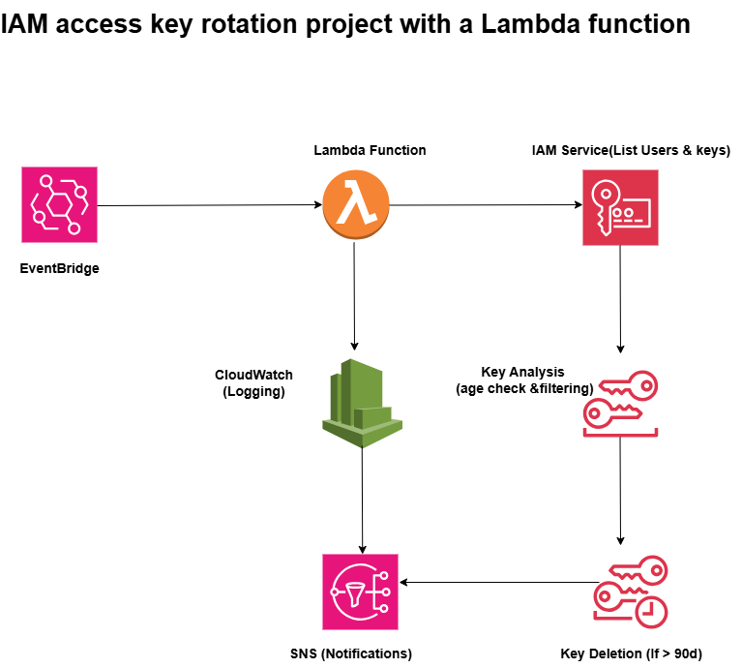

2.2 Process Flow
- Trigger: EventBridge initiates Lambda execution
- Discovery: Lambda lists all IAM users in account
- Key Analysis: For each user, check access key creation dates
- Filtering: Skip excluded users and keys under threshold
- Deletion: Remove keys older than 90 days (or dry-run log)
- Reporting: Log results and send SNS notification
- Completion: Return execution summary

3. Environment Variables
Variable | Default | Description
DRY_RUN | true | Set to false for actual deletion
DAYS_THRESHOLD | 90 | Age limit for key deletion

4. Deployment Guide

4.1 Quick Setup Steps
- Create Lambda Function
  - Use provided Python code
  - Set runtime to Python 3.9
  - Configure environment variables (start with DRY_RUN=true)
- Create IAM Role
  - Attach Lambda execution policy
  - Add IAM permissions for user/key operations
  - Optional: Add SNS publish permissions
- Configure Scheduling
  - Create EventBridge rule (e.g., monthly: rate(30 days))
  - Set Lambda function as target
  - Grant EventBridge invoke permissions
- Testing
  - Execute manually in dry-run mode
  - Review CloudWatch logs
  - Verify expected keys are identified
- Production
  - Set DRY_RUN=false
  - Enable EventBridge rule
  - Monitor first few executions

4.2 Safety Checklist
- ✅ Test in dry-run mode first
- ✅ Configure excluded users list
- ✅ Set appropriate age threshold
- ✅ Verify IAM permissions are minimal
- ✅ Test SNS notifications
- ✅ Review execution logs

5. Compliance Benefits
- Regular Cleanup: Automated credential lifecycle management
- Documentation: Detailed logs for audit purposes
- Policy Enforcement: Consistent application of age thresholds
- Risk Reduction: Minimizes exposure window for old credentials

6. Advanced Configuration

(Custom Scheduling Options)
- Daily: rate(1 day) - For high-security environments
- Weekly: rate(7 days) - Balanced approach
- Monthly: rate(30 days) - Standard compliance schedule

